**EXPERIMENT – 4**

**OBJECTIVE: - Compose & send a professional email with an attachment as “you are applying for an internship, send email to HR with your resume attached”.**

**EXPERIMENT – 5**

**OBJECTIVE: - Design a complete Google Form survey and analyse responses.**

**a) Create a Google Form titled “Student Attendance Report”.**

**b) Include the following question types:**

**i. 5 MCQs**

**ii. 1 Rating scale (1–5)**

**iii. 1 Short answer**

**iv. 1 Checkbox question**

**c) Customize the theme (header image + colour).**

**d) Share the form link with 5 friends and collect responses.**

**e) Generate charts from responses and take screenshots of the analysis page.**

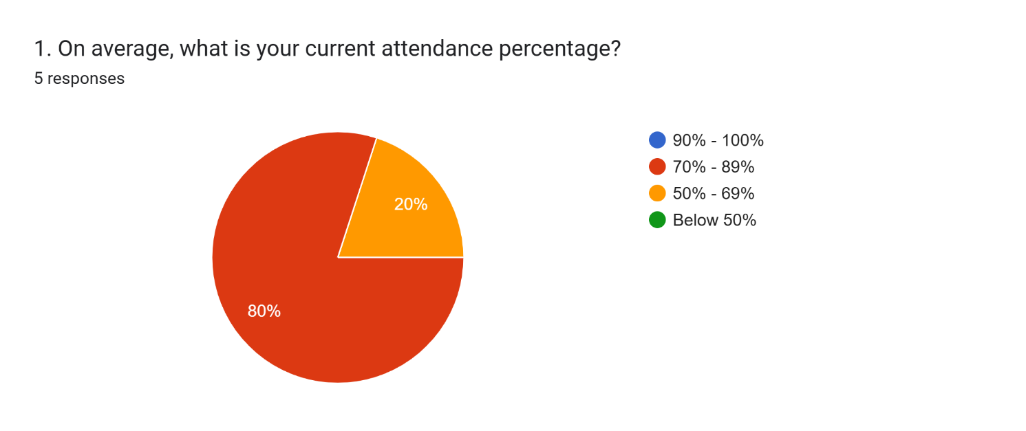

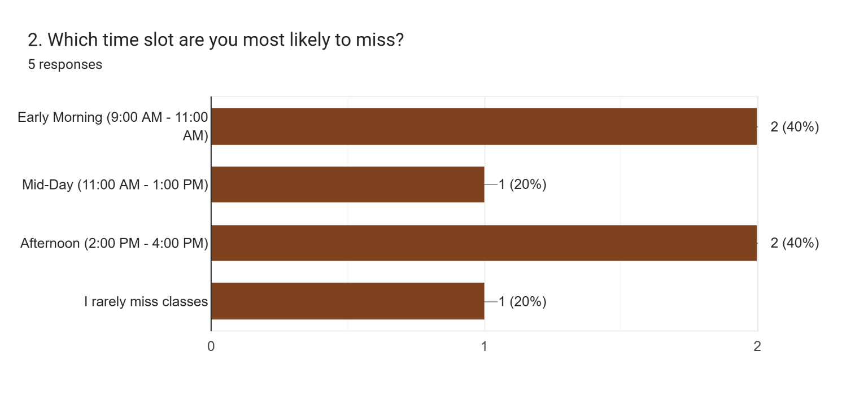

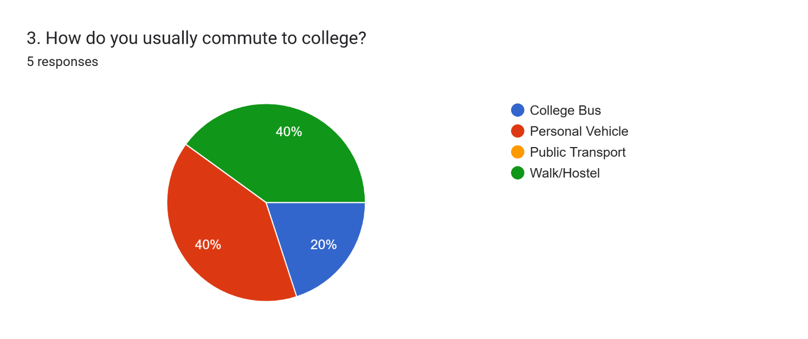

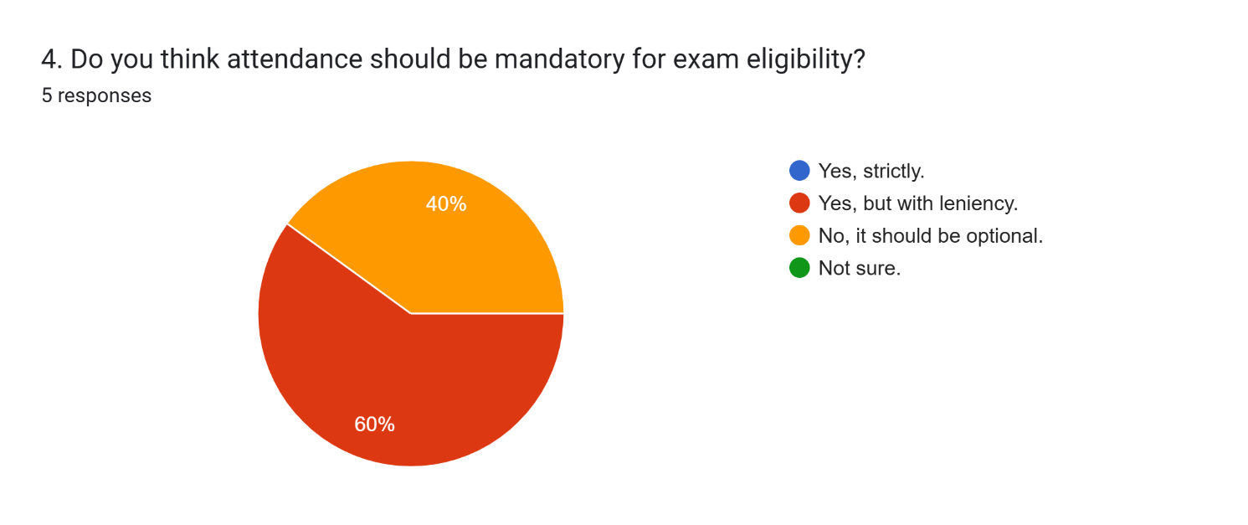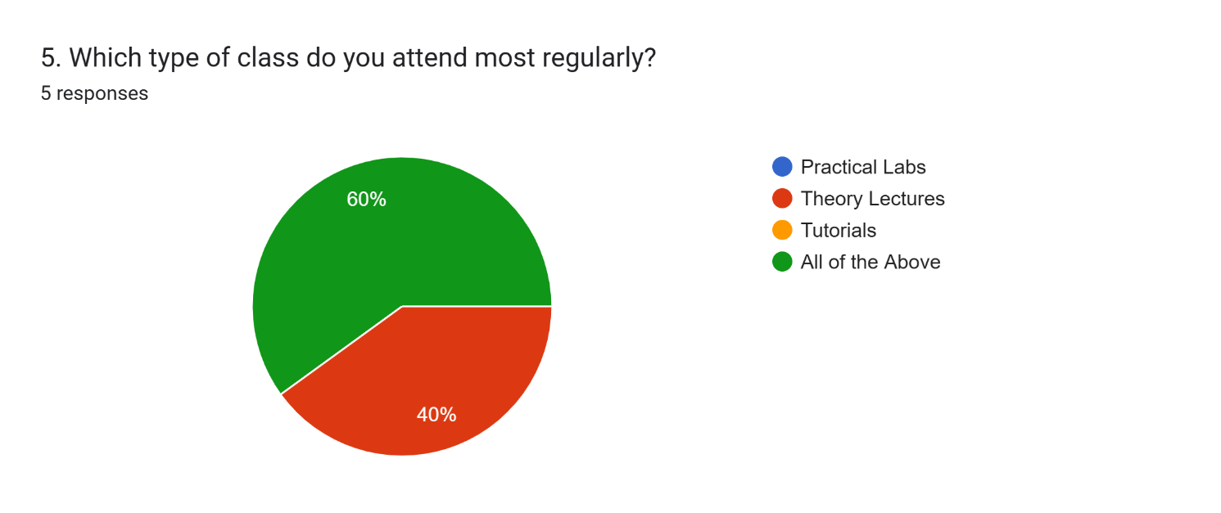

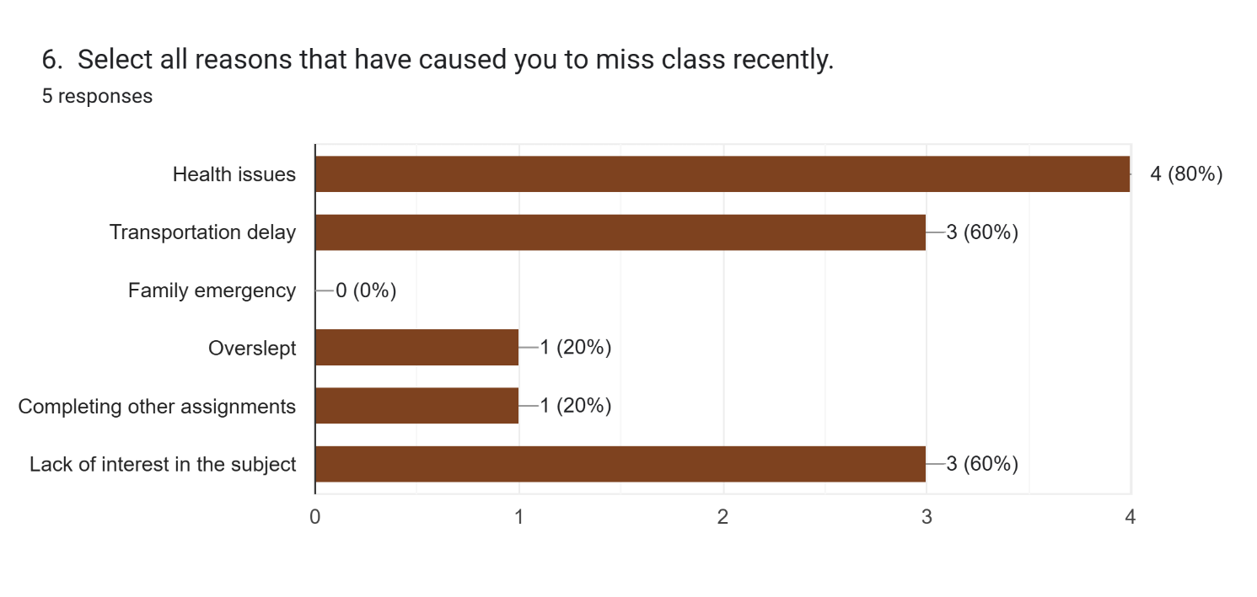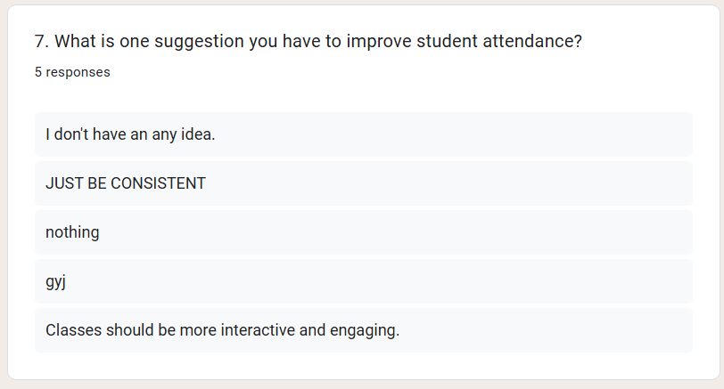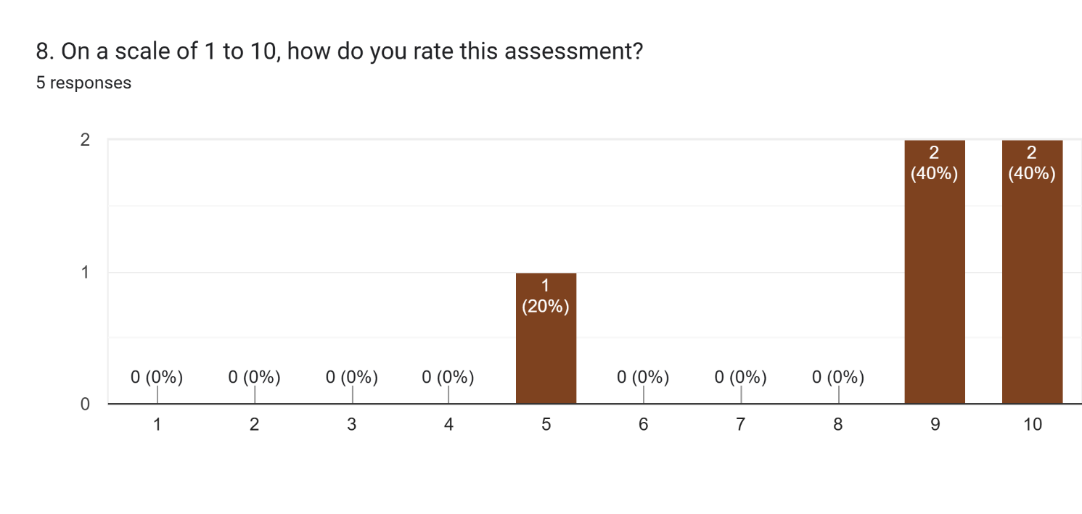

**EXPERIMENT – 6**

**OBJECTIVE: - Demonstrate the creation and management of your digital identity.**

**a) Create a social media profile (LinkedIn preferred).**

**b) Add a profile photo, short bio, skills, and education details.**

**c) Create a simple post about “My Learning Journey in Digital Literacy.”**

**d) Change your privacy settings to:**

**e) Who can see your posts.**

**f) Who can message you**

**EXPERIMENT – 7**

**OBJECTIVE: - Using Google Drive or OneDrive:**

**a) Create a new folder named “Unit 3 Practical Work”.**

**b) Upload 3 different files (PDF, image, document).**

**c) Organize them in subfolders: Notes, Images, Assignments.**

**d) Share the main folder with your teacher with View Only permission.**

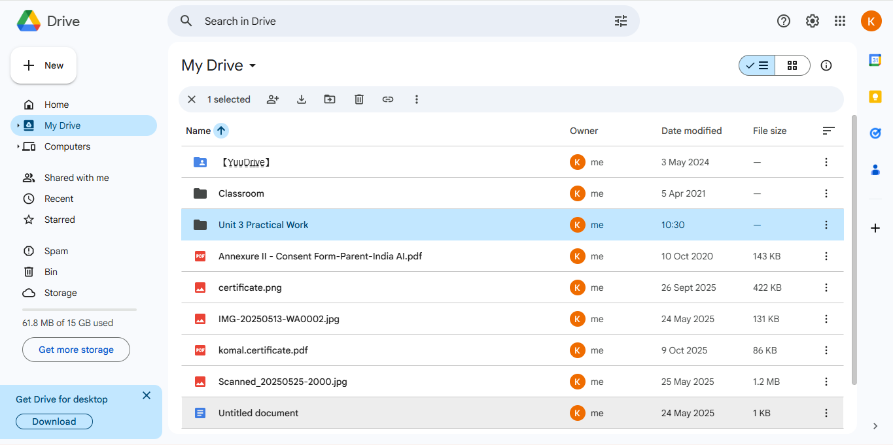

**EXPERIMENT – 8**

**OBJECTIVE: - Identify one real phishing email: A final-year student, Aman, receives a LinkedIn message saying:**

**“You are shortlisted for a Remote Software Developer role at Google.**

**Salary: ₹18 LPA. Pay ₹2,499 as verification fee. Limited seats. Pay now to confirm.”**

**ANSWER THE QUESTIONS: -**

**a. What type of cybercrime is happening here?**

**b. List of 3 red flags that show it is a scam.**

**c. What should he do to verify if a job offer is real?**

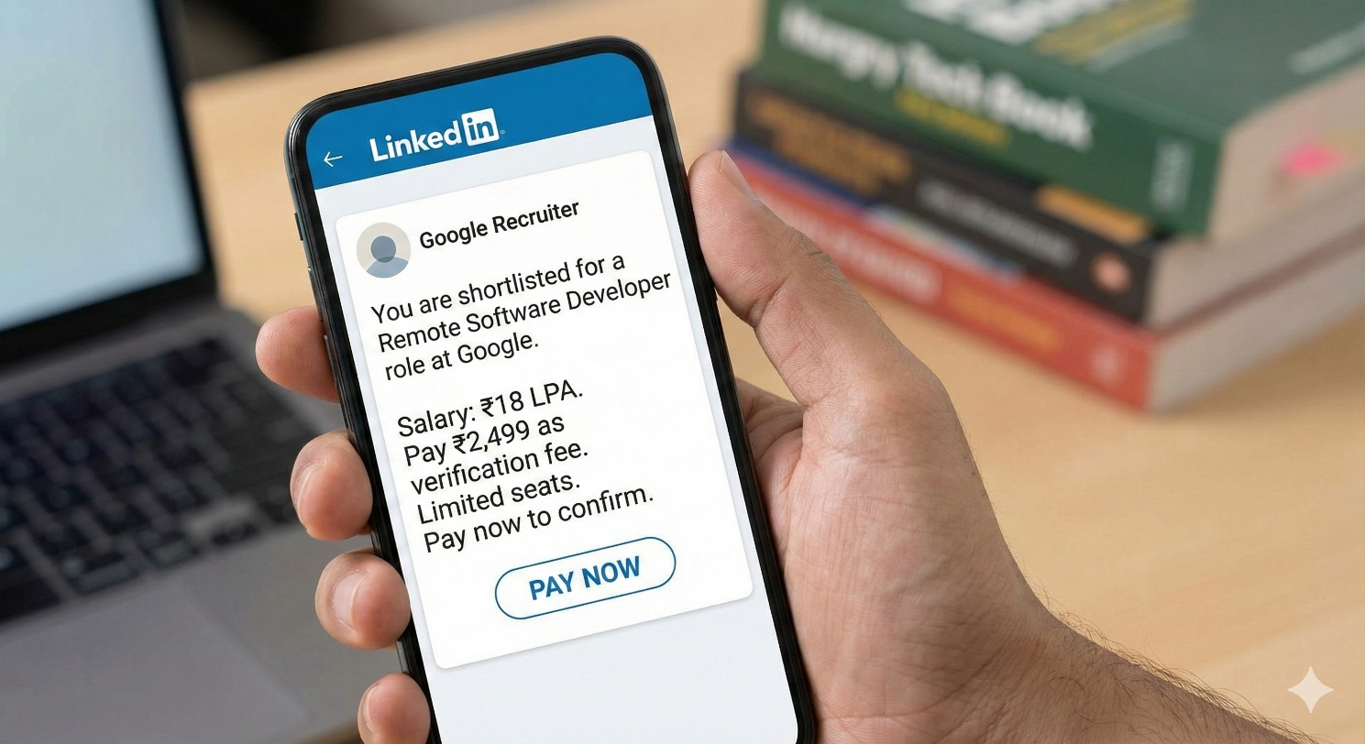



**a. What type of cybercrime is happening here?**

**Phishing (Job Scam / Online Fraud)**

**The scammer is impersonating a reputed company (Google) to trick the victim into paying money.**

**b. Three red flags that show it is a scam**

* 1. **Payment demanded – Genuine companies never ask for a verification or registration fee for jobs.**
  2. **Unrealistic offer – ₹18 LPA for a remote role via a simple LinkedIn message, especially for a student, is highly suspicious.**
  3. **Urgency pressure – Phrases like “Limited seats” and “Pay now to confirm” are common tactics used to rush victims.**

**c. What should he do to verify if a job offer is real?**

* 1. **Check the official company website (Google Careers page) for the same job listing.**
  2. **Verify the sender’s profile and email domain (real Google emails end with @google.com).**
  3. **Contact the company directly through official HR channels or LinkedIn’s verified company page—never through payment link.**

**EXPERIMENT – 9**

**OBJECTIVE: - Create a Google Form Quiz with the following requirements: -**

**(a) Convert the form into a Quiz mode with automatic grading.**

**(b) Add 5 MCQ questions, each carrying 2 marks.**

**(c) Add 1 short answer question that requires manual evaluation.**

**i. Turn ON the setting:**

**ii. Limit to 1 response**

**iii. Shuffle question order**

**iv. Release marks after manual review**

**(d) Add a timer add-on (like form presenter) and set up a 10-minute time limit.**

**(e) Finally, send the quiz link and view the response summary.**

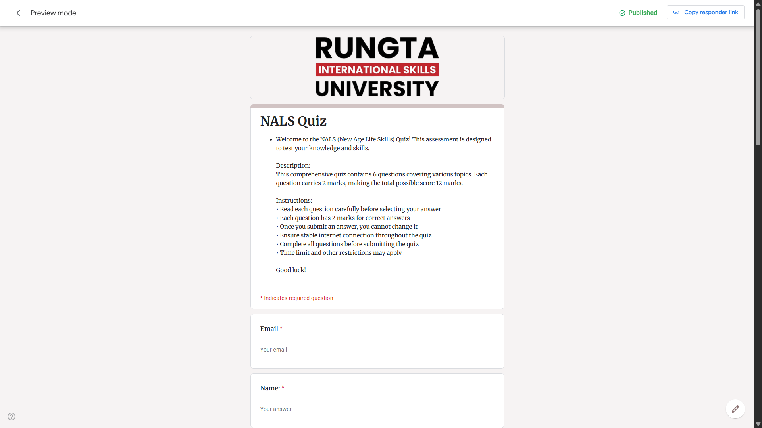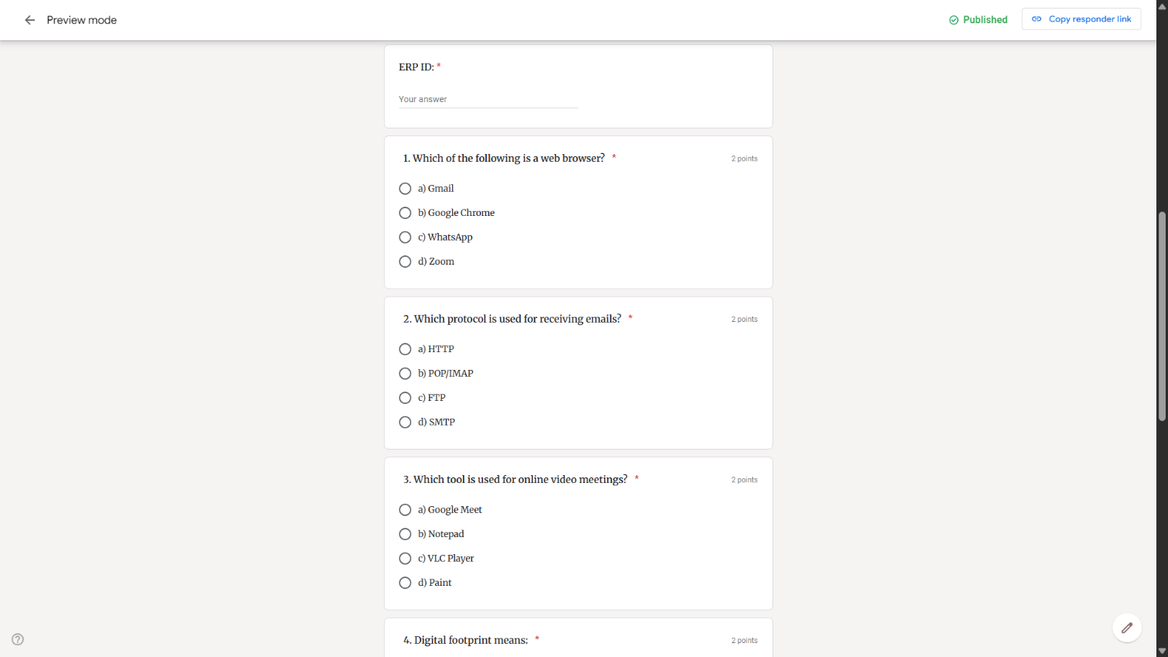

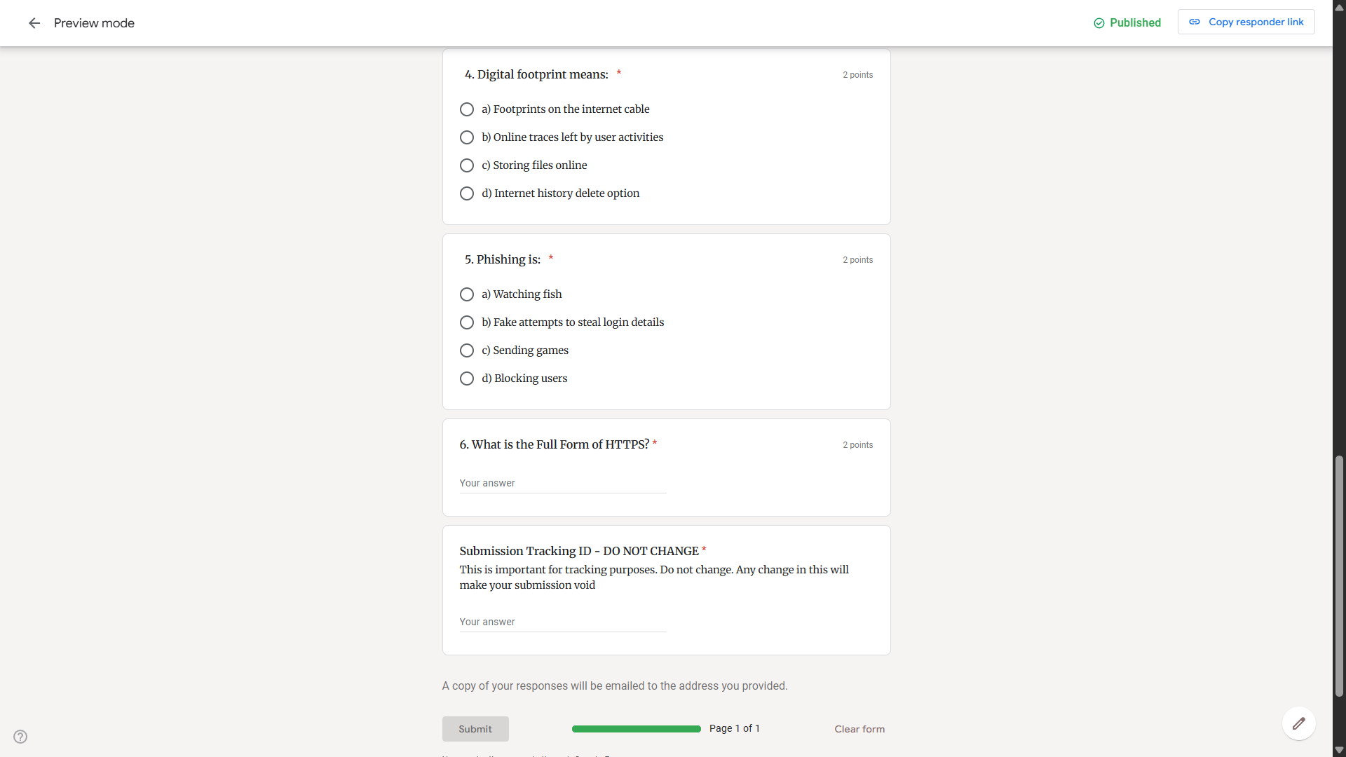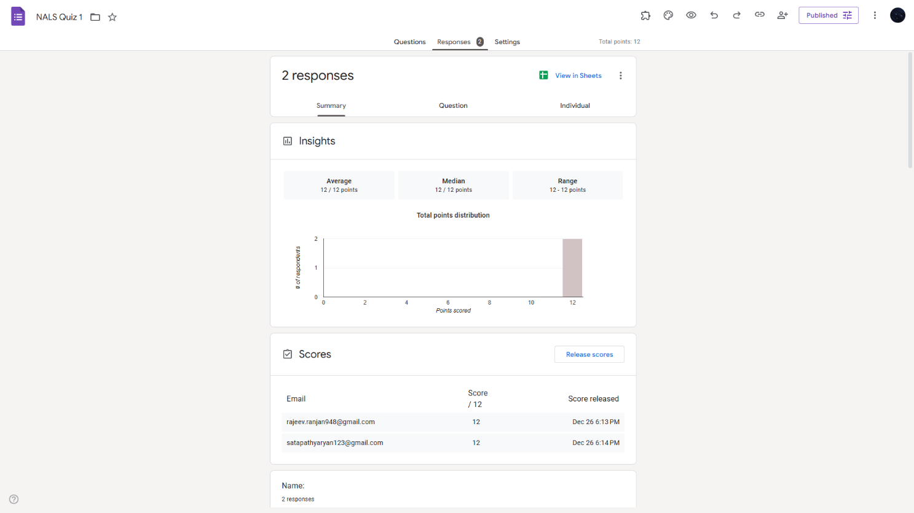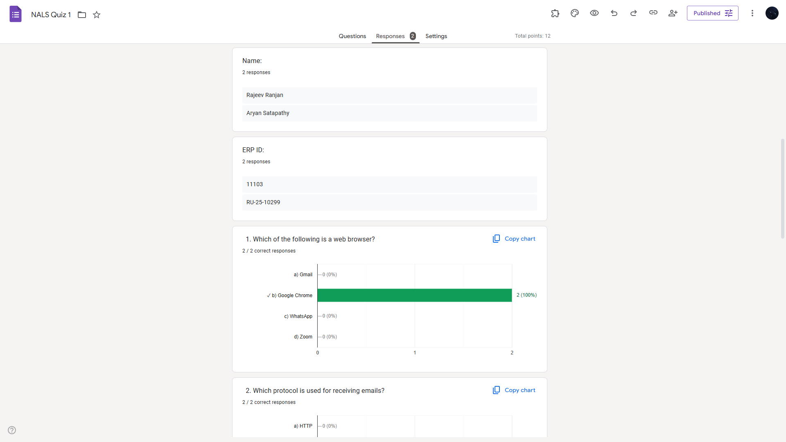

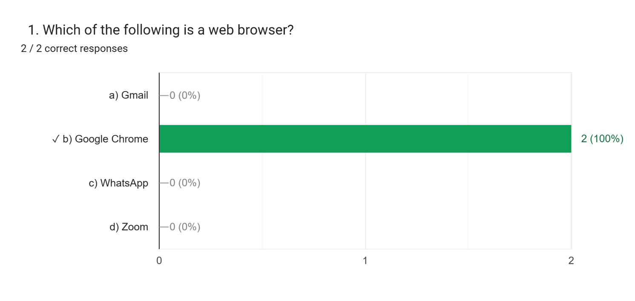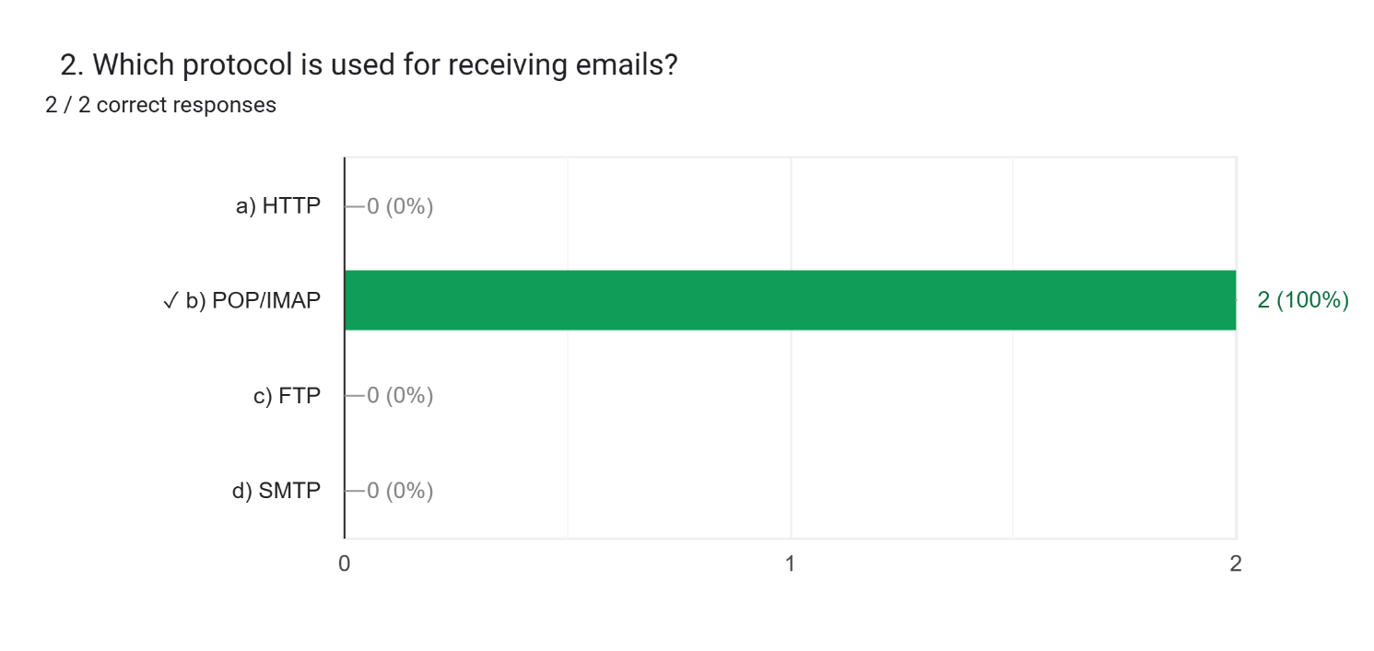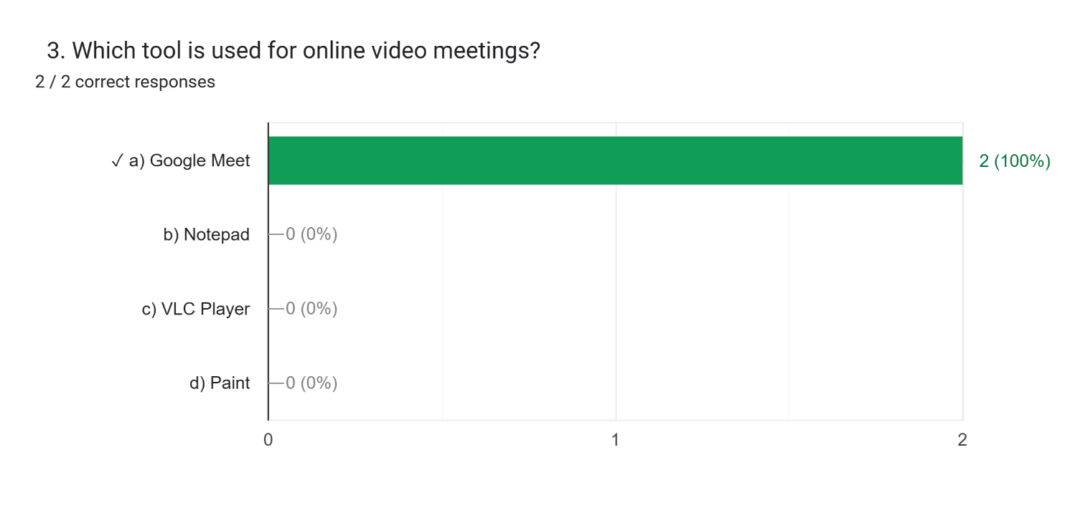

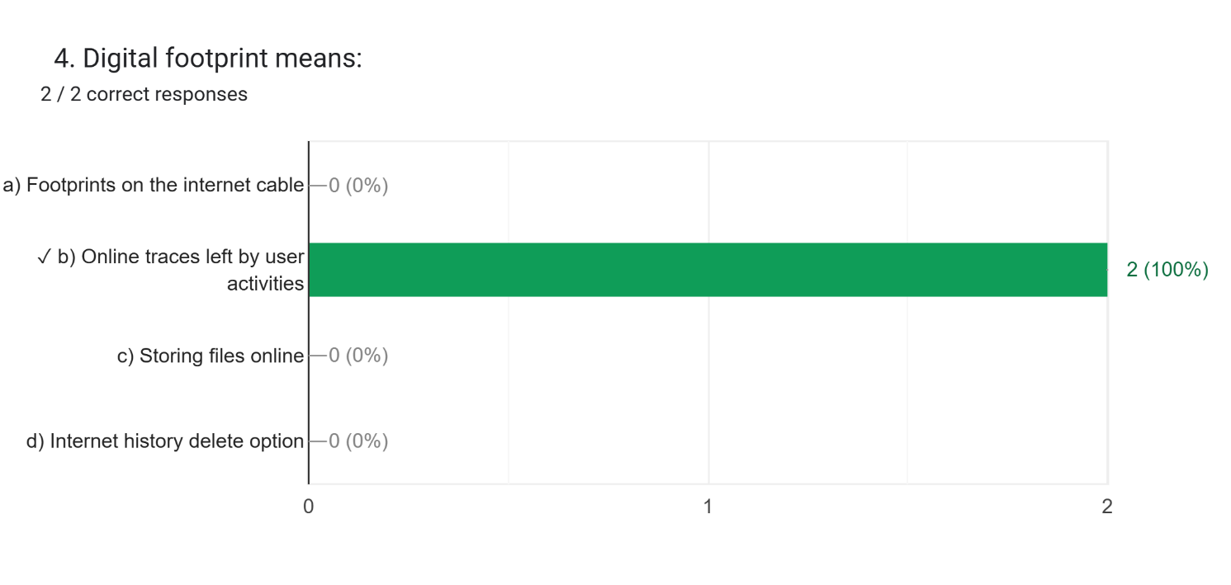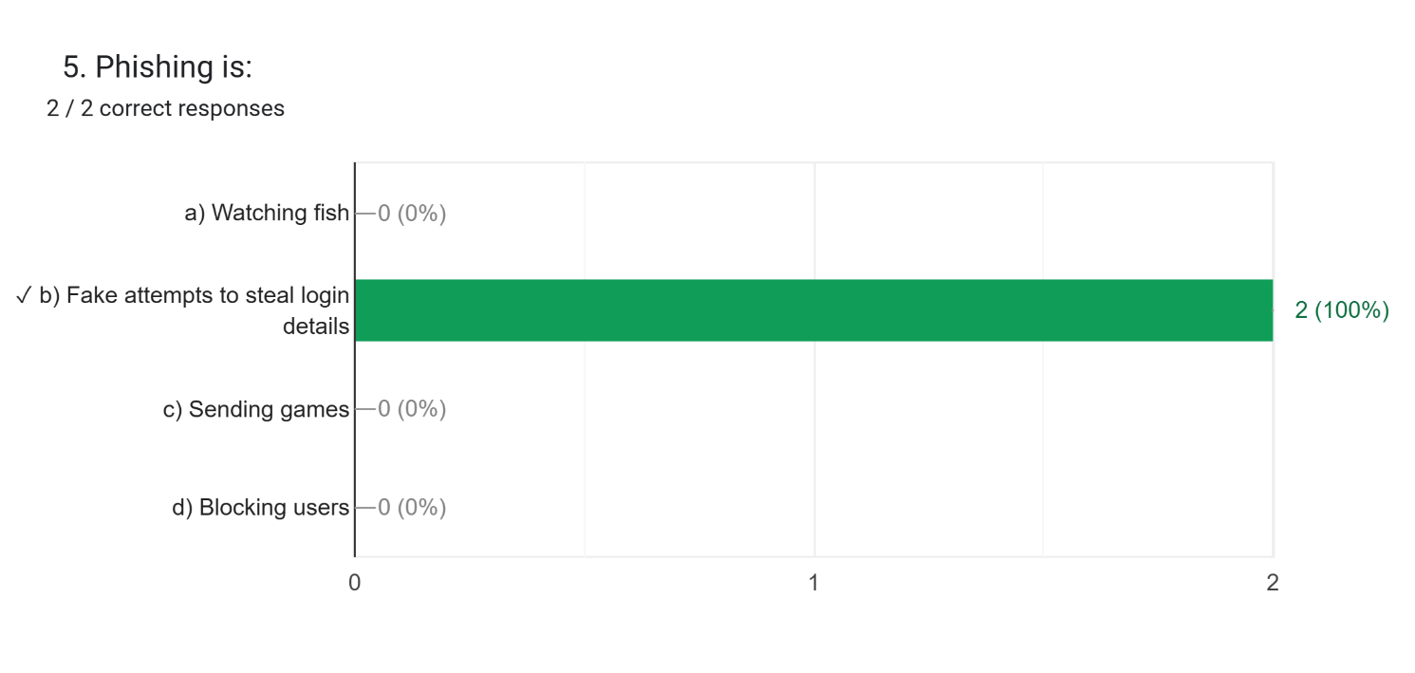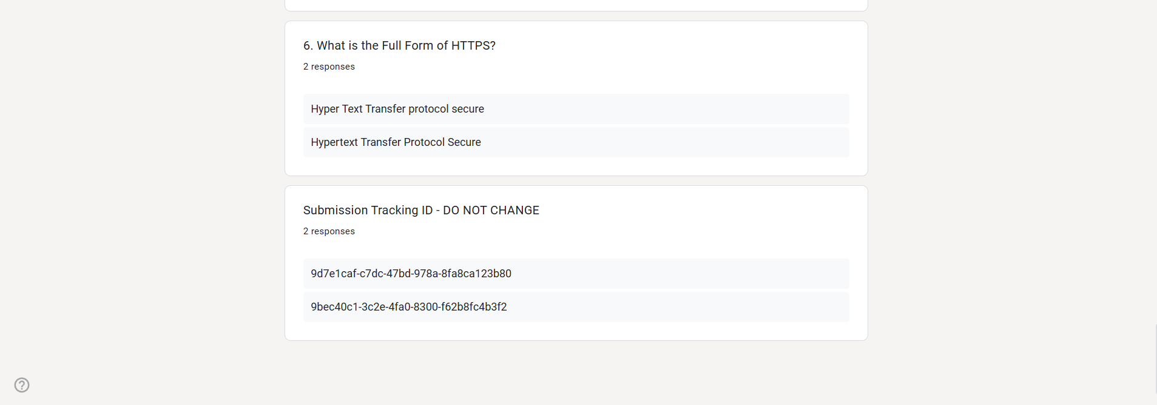

**EXPERIMENT – 10**

**OBJECTIVE: - Ask ChatGPT OR Google Gemini to generate a 100–120-word paragraph on:**

**“Is online learning better than offline learning for college students?”**

**(a) Run the AI-generated text through Grammarly and any plagiarism-check tool.**

**(b) Now manually search online to check if similar sentences exist on blogs or articles.**

**(c) Identify 2–3 biased statements in the AI answer, such as:**

**i. Overgeneralizations**

**ii. One-sided opinions**

**iii. Unproven claims**

**(d) Rewrite the entire paragraph in a neutral and balanced way, using AI only for grammar suggestions.**

**(e) Submit 3 screenshots:**

**i. Plagiarism check results**

**ii. Grammarly suggestion page**

**iii. Original AI paragraph vs your rewritten unbiased version**

**ChatGPT Generated: -**

**Online learning offers college students flexibility and access to a wide range of resources, enabling them to study asynchronously and balance jobs or family responsibilities. High-quality online courses can deliver structured content, multimedia, and collaboration tools that support diverse learning styles. However, remote formats can reduce spontaneous in-person interactions and make it harder to practise interpersonal skills, lab work, or hands-on projects that benefit from physical presence. Outcomes often depend on course design, student motivation, and access to reliable technology. For many students, blended models that combine online content with face-to-face sessions provide the best balance — pairing the scalability and convenience of digital learning with the social, practical, and mentoring benefits of traditional classrooms.**

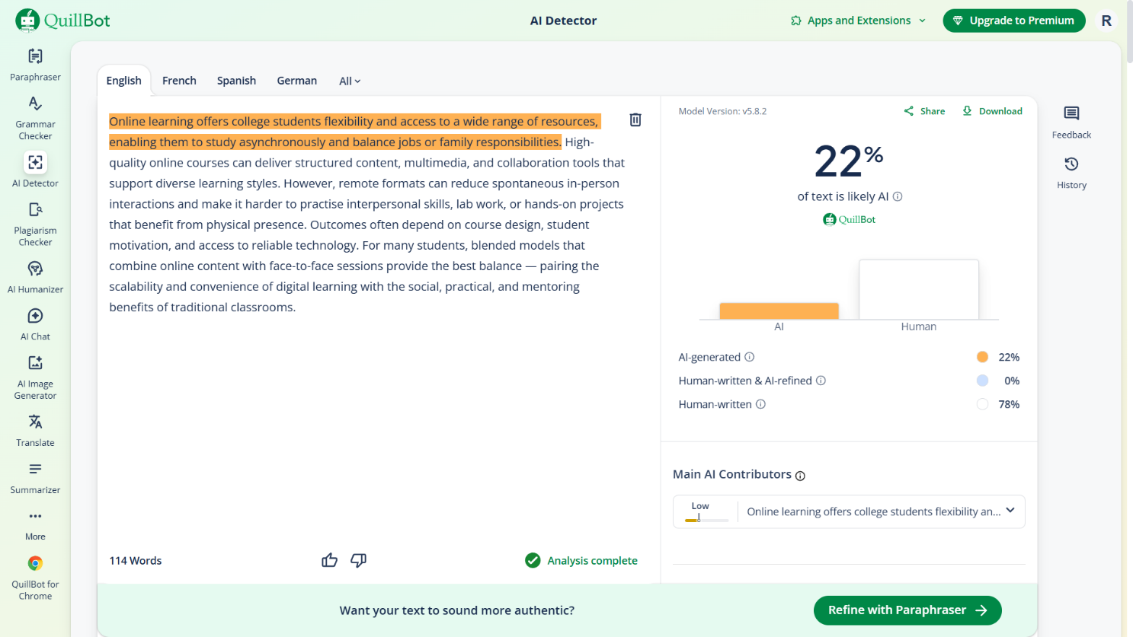

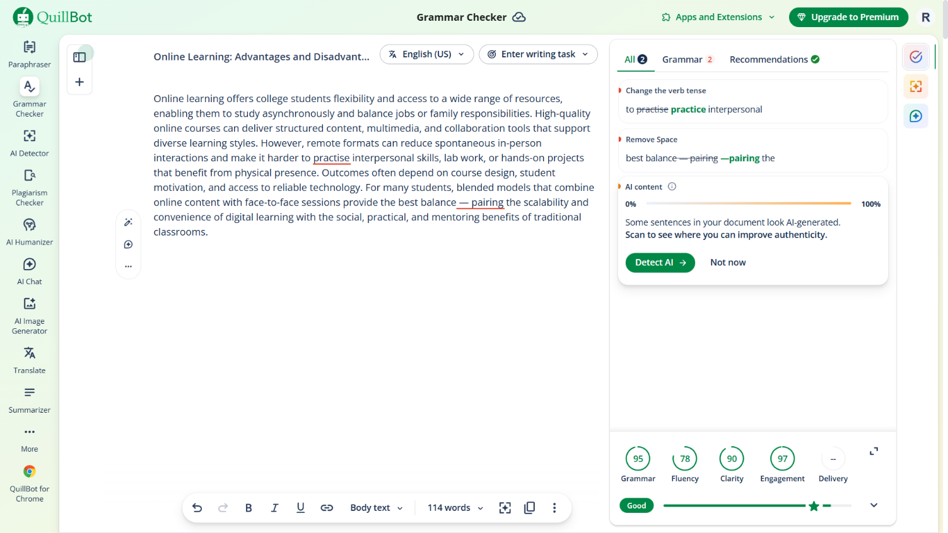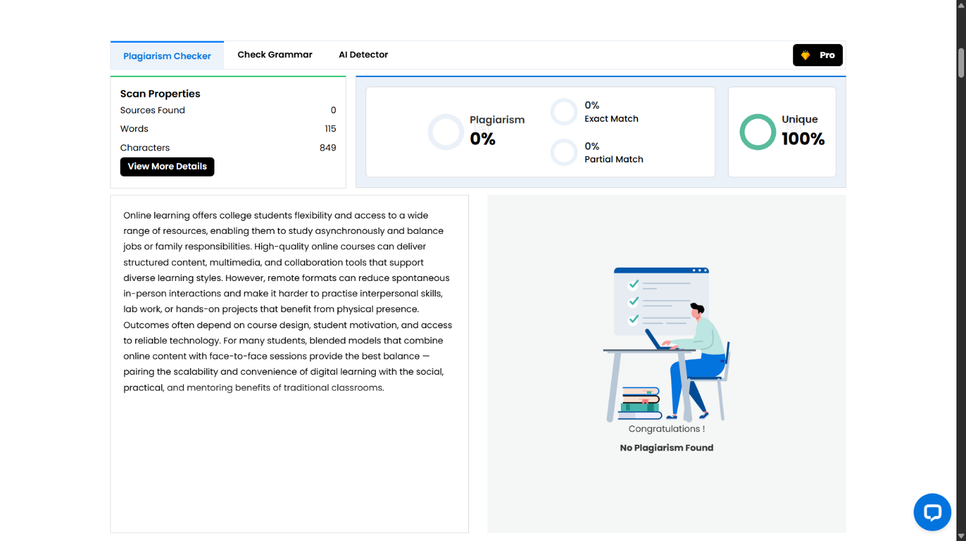

**Rewrite: -**

**Online learning is an innovation in learning mode brought by the inevitability of information and communication technology. The present study highlights the benefits of online learning for students. The study was conducted as library research, where previous studies on the benefits of online learning were used as the data source. The study revealed that online learning is argued to have positively affected students' autonomy, motivation, and collaboration skills while providing flexible learning for the learners. The abundance of online sources, tools, and networking enables learners to navigate their learning. These results imply that teachers, educators, and students should embrace online learning and its supporting applications to improve learning processes and outcomes. The present study contributes to the limited literature on a general overview of online learning benefits seen from the learners' side.**

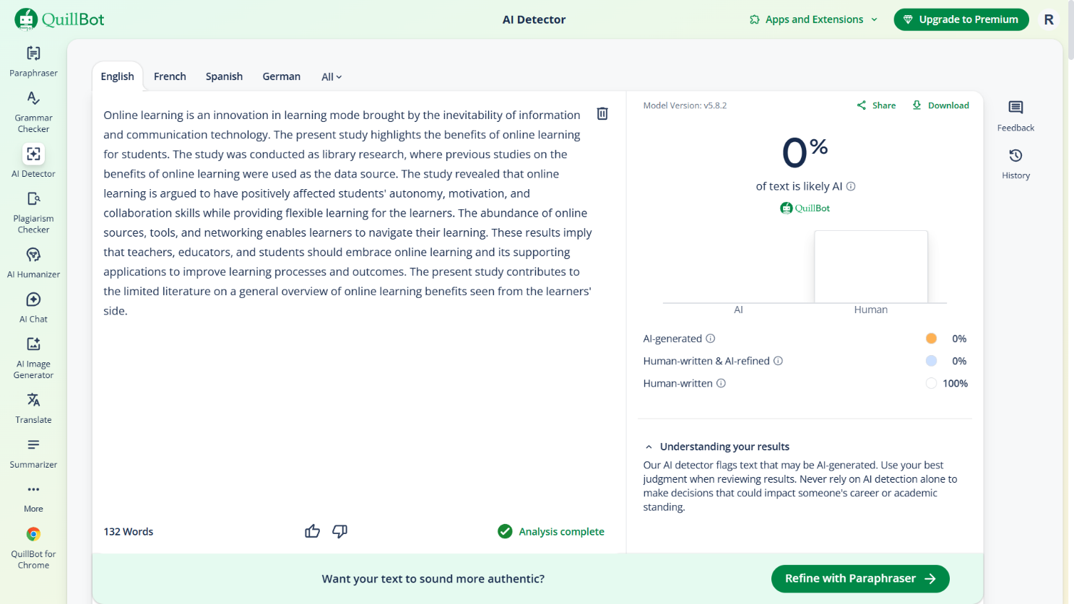

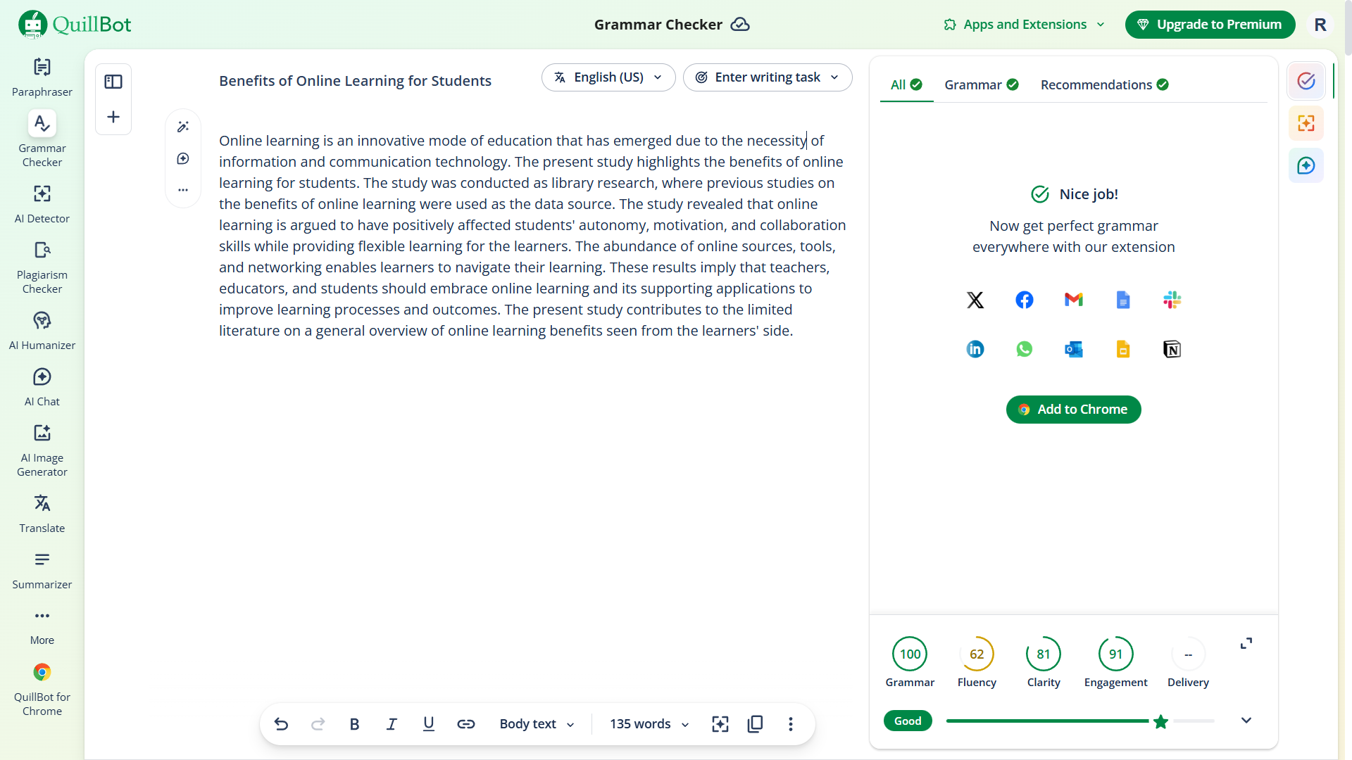

**EXPERIMENT – 11**

**OBJECTIVE: - To compare AI-generated content with student-created content and understand limitations of AI.**

**(a) Write a 100–150-word paragraph on the topic:**

**“Will AI replace jobs or change them?”**

**(This must be written by the student.)**

**(b) Ask any AI tool (ChatGPT/Gemini/Copilot) to write the same topic.**

**(c) In your practical copy, create a Comparison Table with the headings:**

**i. Human-Generated Content**

**ii. AI-Generated Content**

**Handwritten: -**

**“Will AI replace jobs or change them?”**

**As we live in the era of AI, the most asked question is whether AI will replace our jobs. My answer to this question is that as we progress through new technology and the era of innovation, an AI will more likely change the job rather than replace it. While AI can do lots of work in a very small amount of time without getting tired, some jobs require human creativity, emotional intelligence, critical thinking, and moral judgment—skills that AI doesn't have. For example, AI can quickly analyze medical data that is necessary for human doctors to make accurate diagnoses, provide patient care, and inform decision-making. AI is a tool that can help us do our tasks in a much more efficient and productive way. AI will reduce some low-skill jobs, creating challenges for workers. However, it will create new jobs such as AI development, data analysis, cybersecurity, and AI ethics. Overall, AI will not replace our jobs; it represents the shift in the nature of work, making adaptability and continuous learning much more important than ever.**

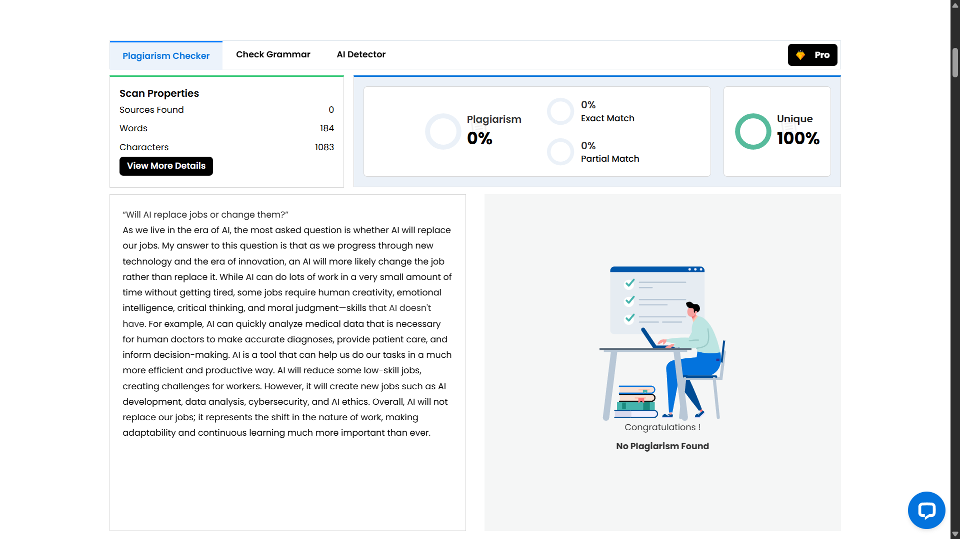

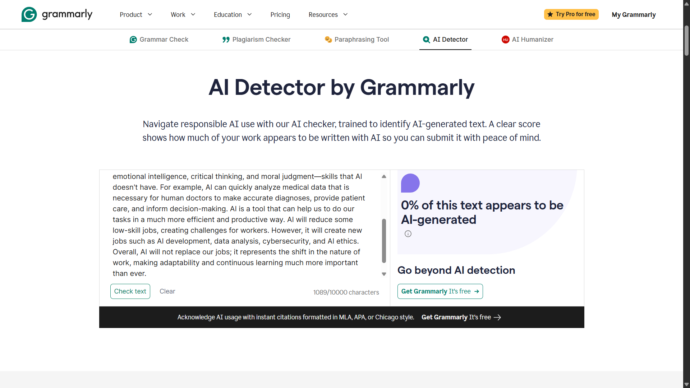

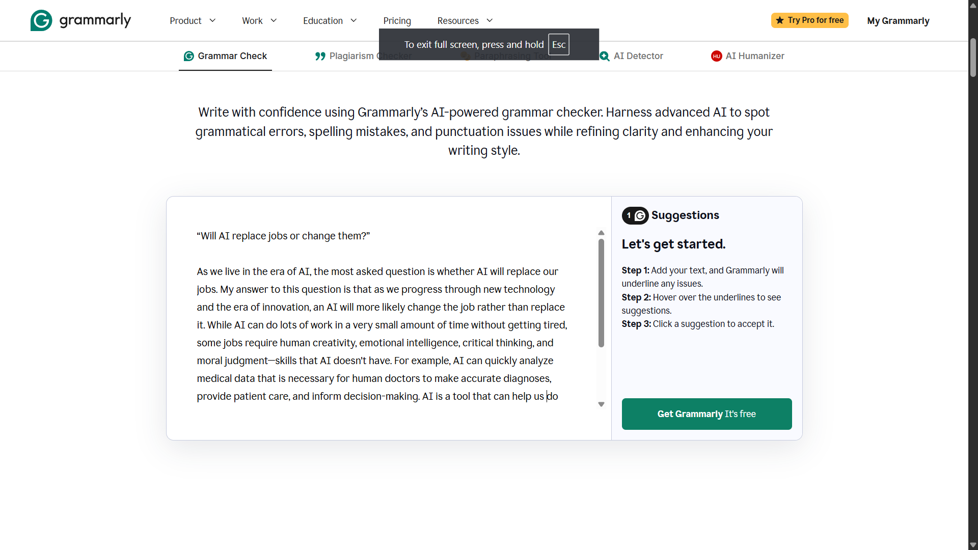

**AI Generated: -**

**Artificial Intelligence is more likely to change jobs than completely replace them. While AI can automate repetitive and routine tasks, many roles still require human creativity, emotional intelligence, critical thinking, and ethical judgment—skills that machines cannot fully replicate. For example, AI can assist doctors by analyzing medical data, but human doctors are still essential for diagnosis, decision-making, and patient care. Similarly, AI tools help teachers, designers, and programmers work more efficiently rather than eliminating their roles. At the same time, AI will reduce demand for certain low-skill or repetitive jobs, creating challenges for workers who lack opportunities to reskill. However, it will also generate new careers in areas such as AI development, data analysis, cybersecurity, and AI ethics. Overall, AI represents a shift in the nature of work, making adaptability and continuous learning more important than ever.**

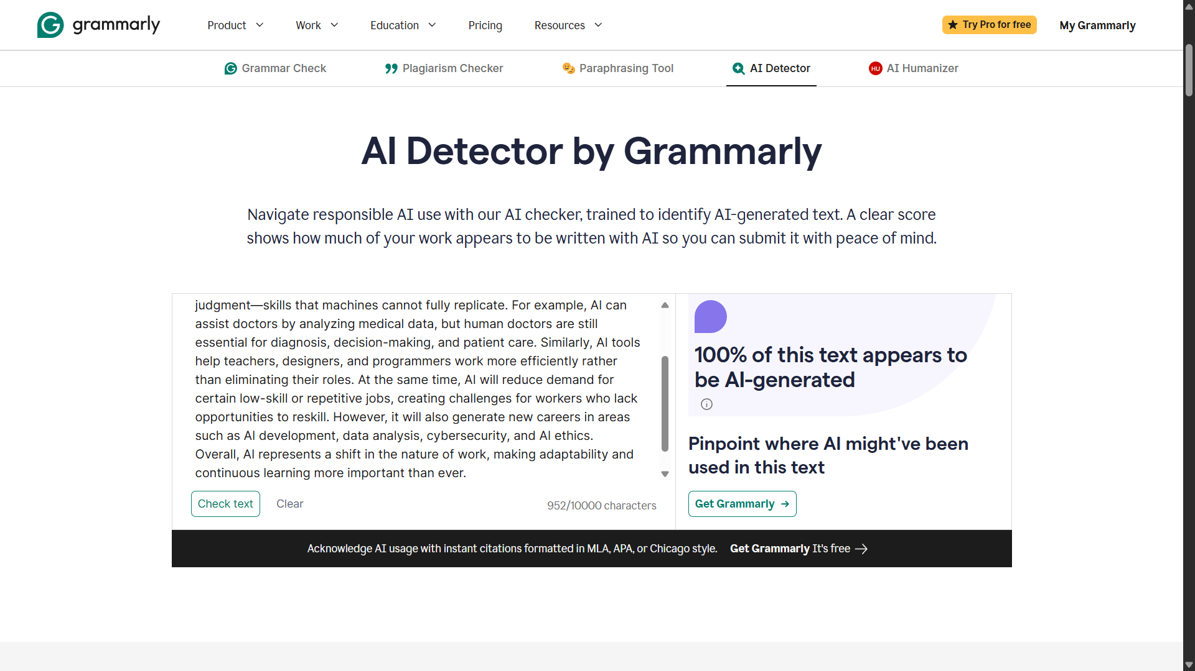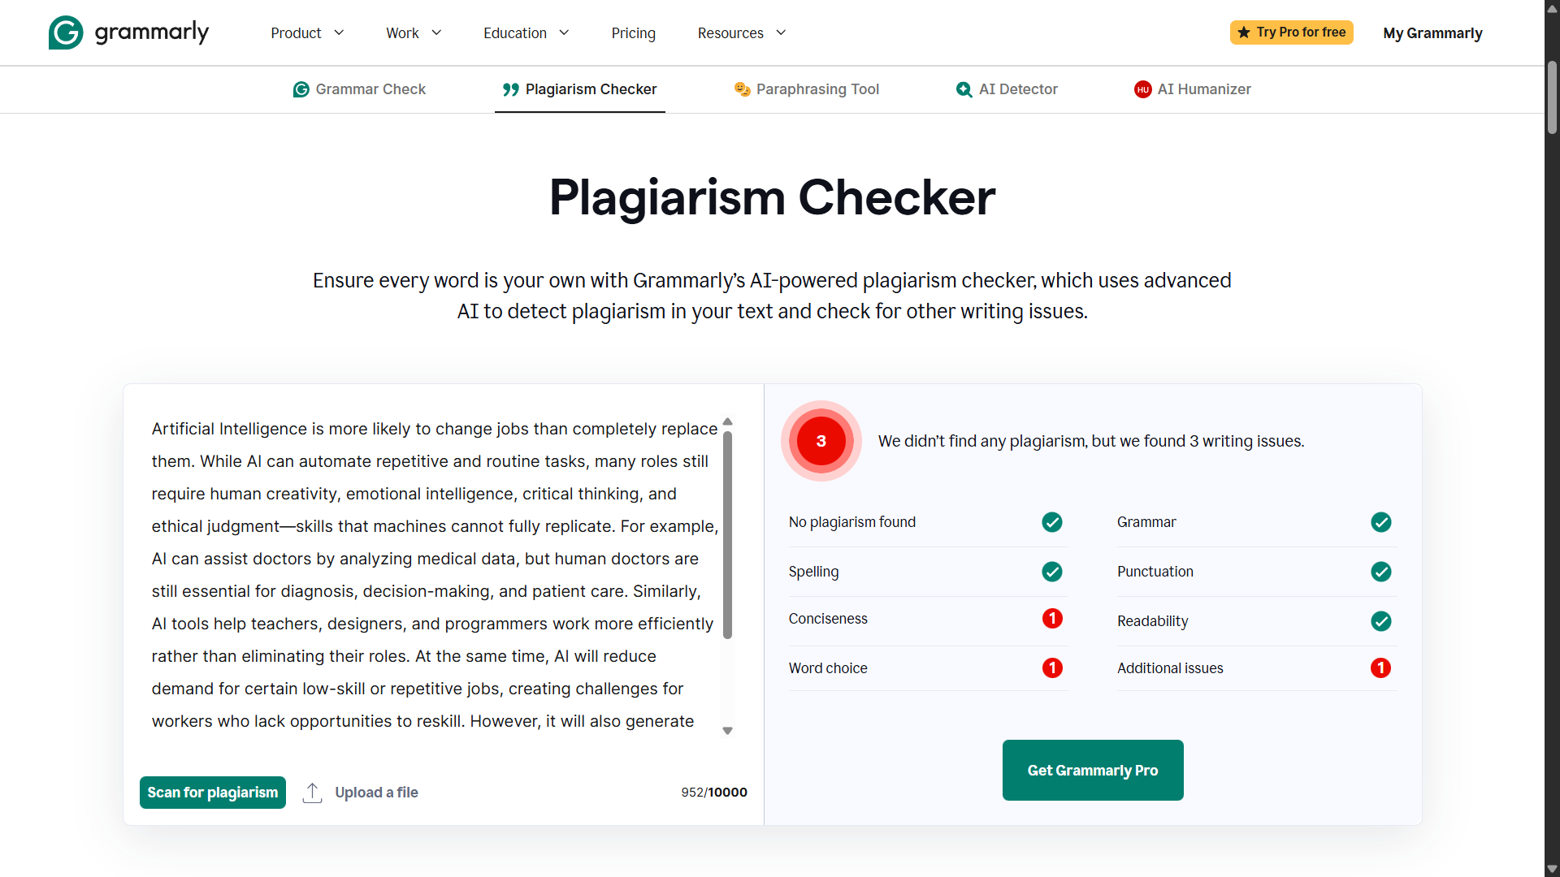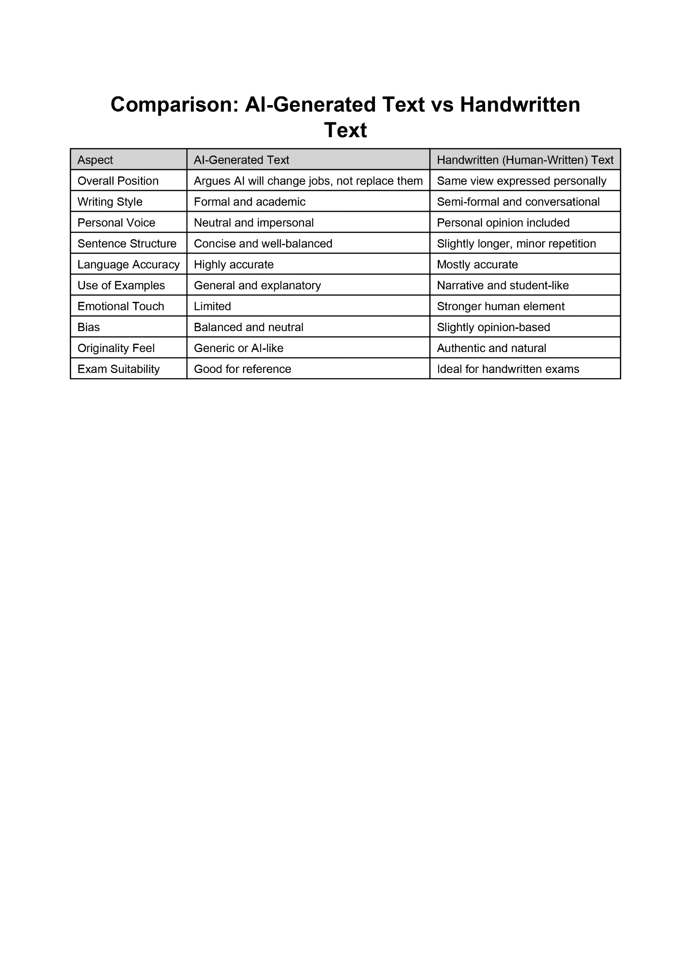

**EXPERIMENT – 12**

**OBJECTIVE: - Create a new Notebook LM project titled: “My Chapter Revision Notes.”**

**(a) Upload multiple sources (any 2) such as:**

**i. PDF notes**

**ii. Web articles**

**iii. Text copied into Notebook LM**

**(b) Ask Notebook LM to:**

**i. Create a combined study guide using all sources.**

**ii. Generate flashcards for quick revision.**

**iii. Create a concept map or explanation of the topic.**

**Manually check for:**

**i. Any incorrect facts**

**ii. Repeated information**

**iii. Missing important points**

**Attach 3 screenshots from Notebook LM:**

**I. Combined study guide**

**ii. Flashcards**

**iii. Concept map / explanation**

**i. Combined study guide: -**

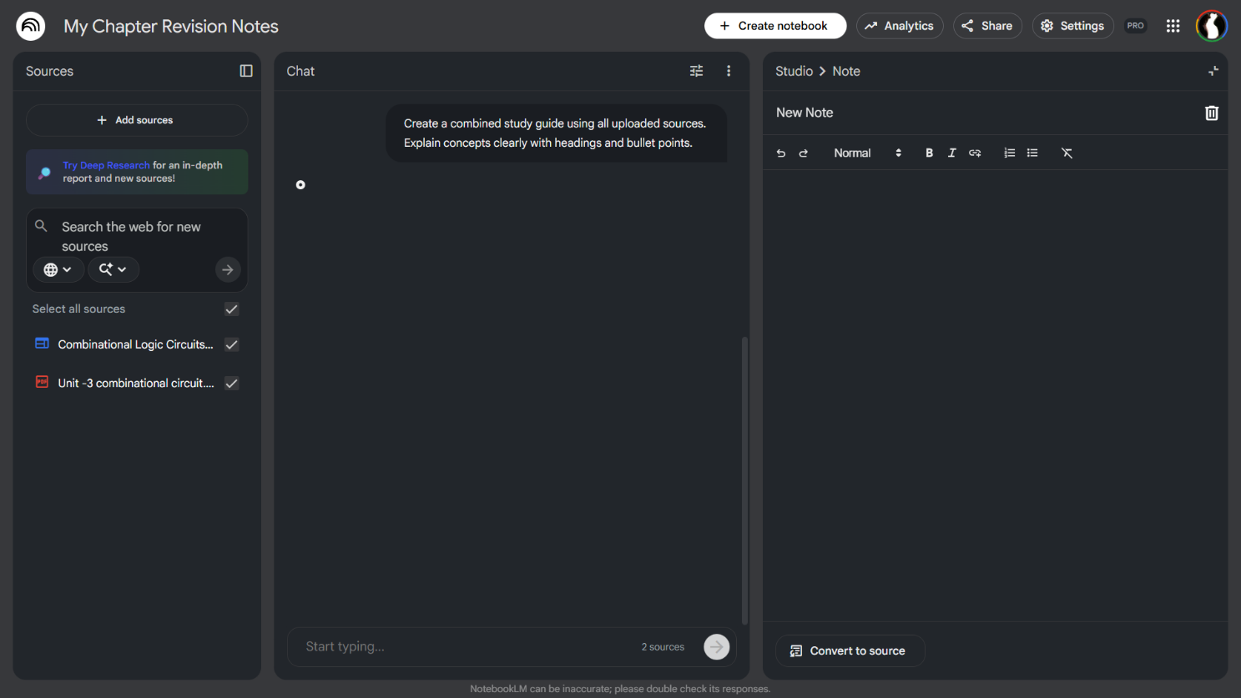

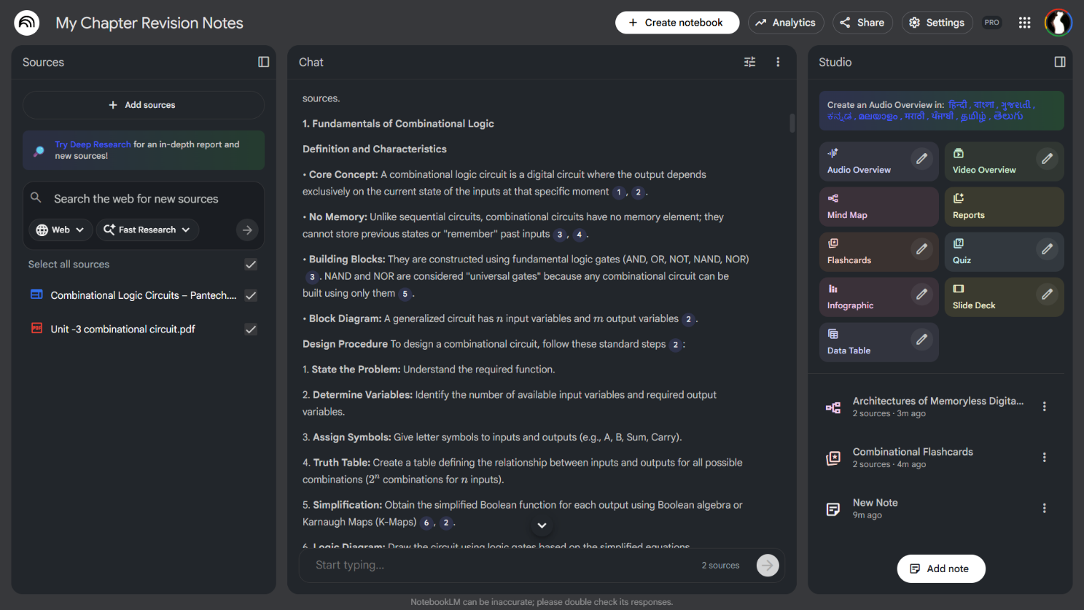

**ii. Flashcards**

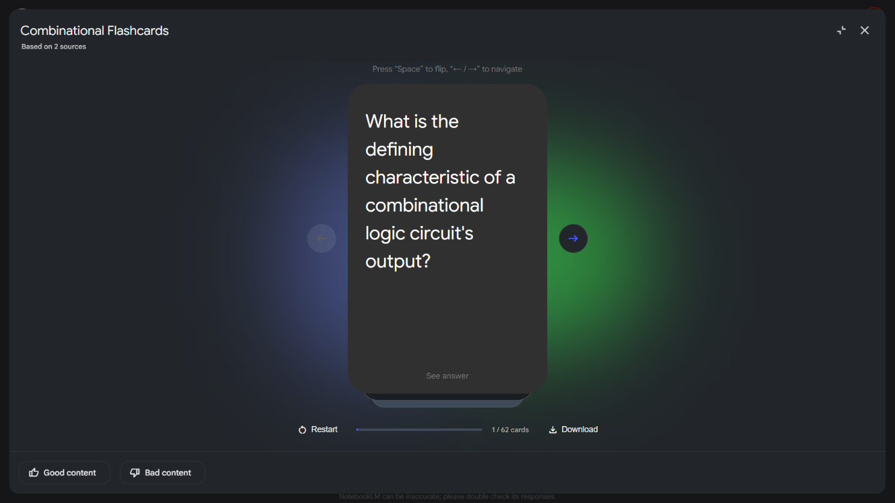

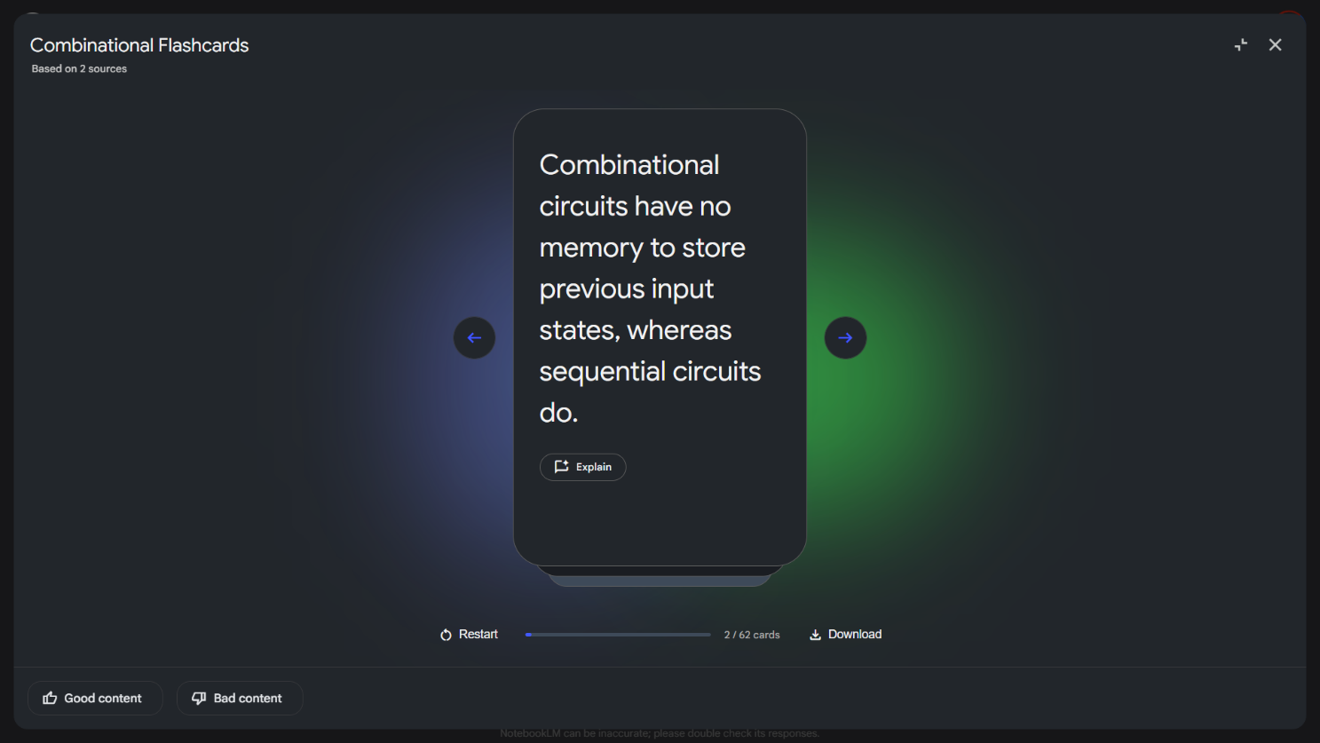

**iii. Concept map / explanation: -**

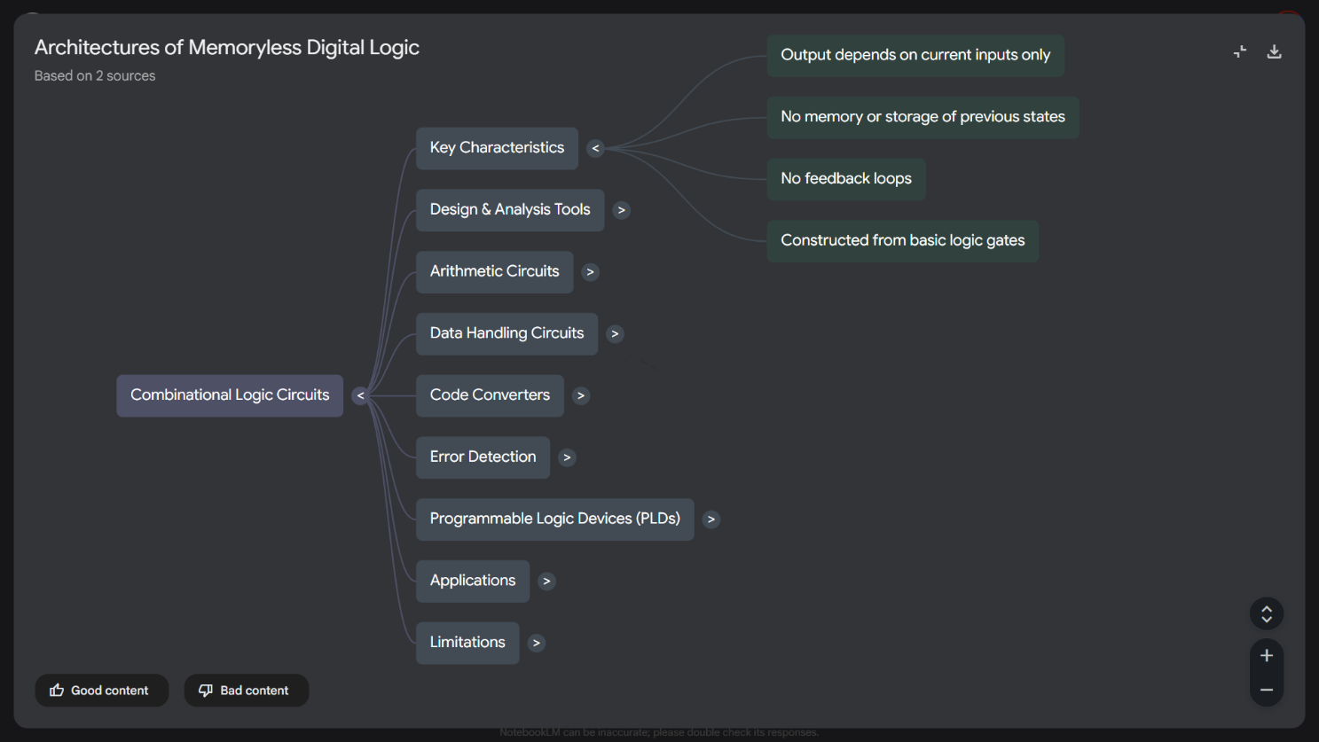

**EXPERIMENT – 13**

**OBJECTIVE: - Create a complete Student Result Management workbook.**

**(a) Create a new workbook with 3 sheets renamed as:**

**i. Student Data**

**ii. Marks Analysis**

**iii. Charts**

**(b) In Student Data, enter a list of 15 students with:**

**(c) Name, Roll No, Class, City, Subject1, Subject2, Subject3.**

**(d) Use Flash Fill to split “Full Name” into “First Name” and “Last Name”.**

**(e) Use Find & Replace to replace city name “Delhii” with correct “Delhi”.**

**(f) Use IF function to calculate Pass/Fail (Pass = total ≥ 120).**

**(g) Use COUNTIF to find how many students belong to “Delhi”.**

**(h) Use AVERAGE, MAX, MIN to analyse marks in the Marks Analysis sheet.**

**(i) On the Charts sheet, create:**

**i. A Bar Chart showing marks of any one subject.**

**ii. A Pie Chart showing percentage of pass vs fail.**

**(j) Apply Conditional Formatting to highlight marks < 40 in red.**

**(k) Convert the table into a formatted Excel Table.**

|  |  |  |  |  |  |  |  |  |
| --- | --- | --- | --- | --- | --- | --- | --- | --- |
| **Full Name** | **Roll No** | **Class** | **City** | **Subject1** | **Subject2** | **Subject3** | **Total** | **Result** |
| Rahul Sharma | 1 | 10A | Delhii | 45 | 50 | 40 | 135 | Pass |
| Anita Verma | 2 | 10A | Delhi | 60 | 55 | 50 | 165 | Pass |
| Amit Singh | 3 | 10B | Delhii | 30 | 40 | 45 | 115 | Fail |
| Neha Gupta | 4 | 10B | Mumbai | 70 | 60 | 65 | 195 | Pass |
| Rohit Kumar | 5 | 10A | Delhi | 55 | 40 | 35 | 130 | Pass |
| Priya Mehta | 6 | 10C | Delhii | 80 | 75 | 70 | 225 | Pass |
| Suresh Yadav | 7 | 10C | Delhi | 50 | 45 | 40 | 135 | Pass |
| Kavita Joshi | 8 | 10A | Pune | 65 | 60 | 55 | 180 | Pass |
| Vikas Patel | 9 | 10B | Delhi | 40 | 35 | 45 | 120 | Pass |
| Pooja Nair | 10 | 10C | Kochi | 75 | 80 | 70 | 225 | Pass |
| Arjun Malhotra | 11 | 10A | Delhii | 55 | 60 | 50 | 165 | Pass |
| Sneha Roy | 12 | 10B | Kolkata | 45 | 50 | 55 | 150 | Pass |
| Manish Jain | 13 | 10C | Delhi | 35 | 40 | 45 | 120 | Pass |
| Riya Chawla | 14 | 10A | Delhii | 60 | 65 | 55 | 180 | Pass |
| Nitin Agarwal | 15 | 10B | Delhi | 70 | 75 | 80 | 225 | Pass |

|  |  |  |  |  |  |
| --- | --- | --- | --- | --- | --- |
| **Subject** | **Average** | **Max** | **Min** | **Result** | **Count** |
| Subject1 | 55.6666667 | 80 | 30 | Pass | 14 |
| Subject2 | 55.3333333 | 80 | 35 | Fail | 1 |
| Subject3 | 53.3333333 | 80 | 35 |  |  |

|  |  |  |  |  |  |  |  |  |
| --- | --- | --- | --- | --- | --- | --- | --- | --- |
| **Full Name** | **Roll No** | **Class** | **City** | **Subject1** | **Subject2** | **Subject3** | **Total** | **Result** |
| Rahul Sharma | 1 | 10A | Delhi | 45 | 50 | 40 | 135 | Pass |
| Anita Verma | 2 | 10A | Delhi | 60 | 55 | 50 | 165 | Pass |
| Amit Singh | 3 | 10B | Delhi | 30 | 40 | 45 | 115 | Fail |
| Neha Gupta | 4 | 10B | Mumbai | 70 | 60 | 65 | 195 | Pass |
| Rohit Kumar | 5 | 10A | Delhi | 55 | 40 | 35 | 130 | Pass |
| Priya Mehta | 6 | 10C | Delhi | 80 | 75 | 70 | 225 | Pass |
| Suresh Yadav | 7 | 10C | Delhi | 50 | 45 | 40 | 135 | Pass |
| Kavita Joshi | 8 | 10A | Pune | 65 | 60 | 55 | 180 | Pass |
| Vikas Patel | 9 | 10B | Delhi | 40 | 35 | 45 | 120 | Pass |
| Pooja Nair | 10 | 10C | Kochi | 75 | 80 | 70 | 225 | Pass |
| Arjun Malhotra | 11 | 10A | Delhi | 55 | 60 | 50 | 165 | Pass |
| Sneha Roy | 12 | 10B | Kolkata | 45 | 50 | 55 | 150 | Pass |
| Manish Jain | 13 | 10C | Delhi | 35 | 40 | 45 | 120 | Pass |
| Riya Chawla | 14 | 10A | Delhi | 60 | 65 | 55 | 180 | Pass |
| Nitin Agarwal | 15 | 10B | Delhi | 70 | 75 | 80 | 225 | Pass |

**EXPERIMENT – 14**

**OBJECTIVE: - Build a workbook for managing and analyzing sales data of a small store.**

**(a) Create a workbook with sheets:**

**i. Store Sales**

**ii. Summary**

**(b) Import a CSV sales file (or create a sample table) containing:**

**Date, Product, Category, Quantity, Price, Total Sales.**

**(c) Use Sort (A→Z, Z→A) to organize products by name and category.**

**(d) Apply Filter to view only “Electronics” category.**

**(e) Use SUMIF to find total sales for a selected product (e.g., “Headphones”).**

**(f) Use LEFT, RIGHT, MID to extract:**

**I. First 3 letters of the product name**

**II. Last 2 letters of the category**

**(g) Find the highest and lowest sales value using MAX/MIN.**

**(h) Prepare a monthly sales summary in the Summary sheet using AVERAGE & SUM.**

**(i) Create a Line Chart of month-wise total sales in the Charts sheet.**

**(j) Apply sheet protection so data cannot be edited accidentally.**

|  |  |  |  |  |  |  |  |
| --- | --- | --- | --- | --- | --- | --- | --- |
| Date | Product | Category | Quantity | Price | Total Sales | Prod_First3 | Cat_Last2 |
| 2025-01-05 | Headphones | Electronics | 5 | 1500 | 7500 | Hea | cs |
| 2025-01-12 | Mouse | Electronics | 10 | 500 | 5000 | Mou | cs |
| 2025-02-03 | Notebook | Stationery | 20 | 80 | 1600 | Not | ry |
| 2025-02-18 | Keyboard | Electronics | 7 | 1200 | 8400 | Key | cs |
| 2025-03-10 | Pen | Stationery | 50 | 20 | 1000 | Pen | ry |
| 2025-03-22 | Speaker | Electronics | 4 | 2500 | 10000 | Spe | cs |

|  |  |
| --- | --- |
| ***Metric*** | **SUM of Value** |
| **Highest Sale** | **10000** |
| **Lowest Sale** | **1000** |
| **Total Sales (Headphones)** | **7500** |
| **Grand Total** | **18500** |

|  |  |
| --- | --- |
| *Month* | SUM of Monthly Total |
| Feb | 1600 |
| Jan | 12500 |
| Mar | 9400 |
| **Grand Total** | **23500** |

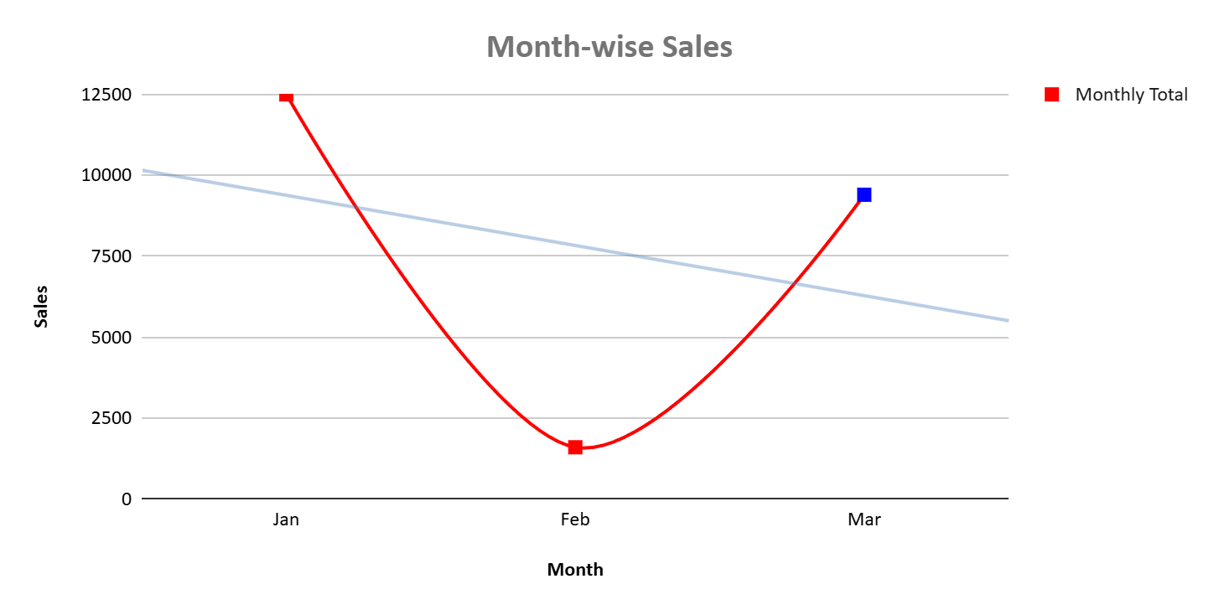

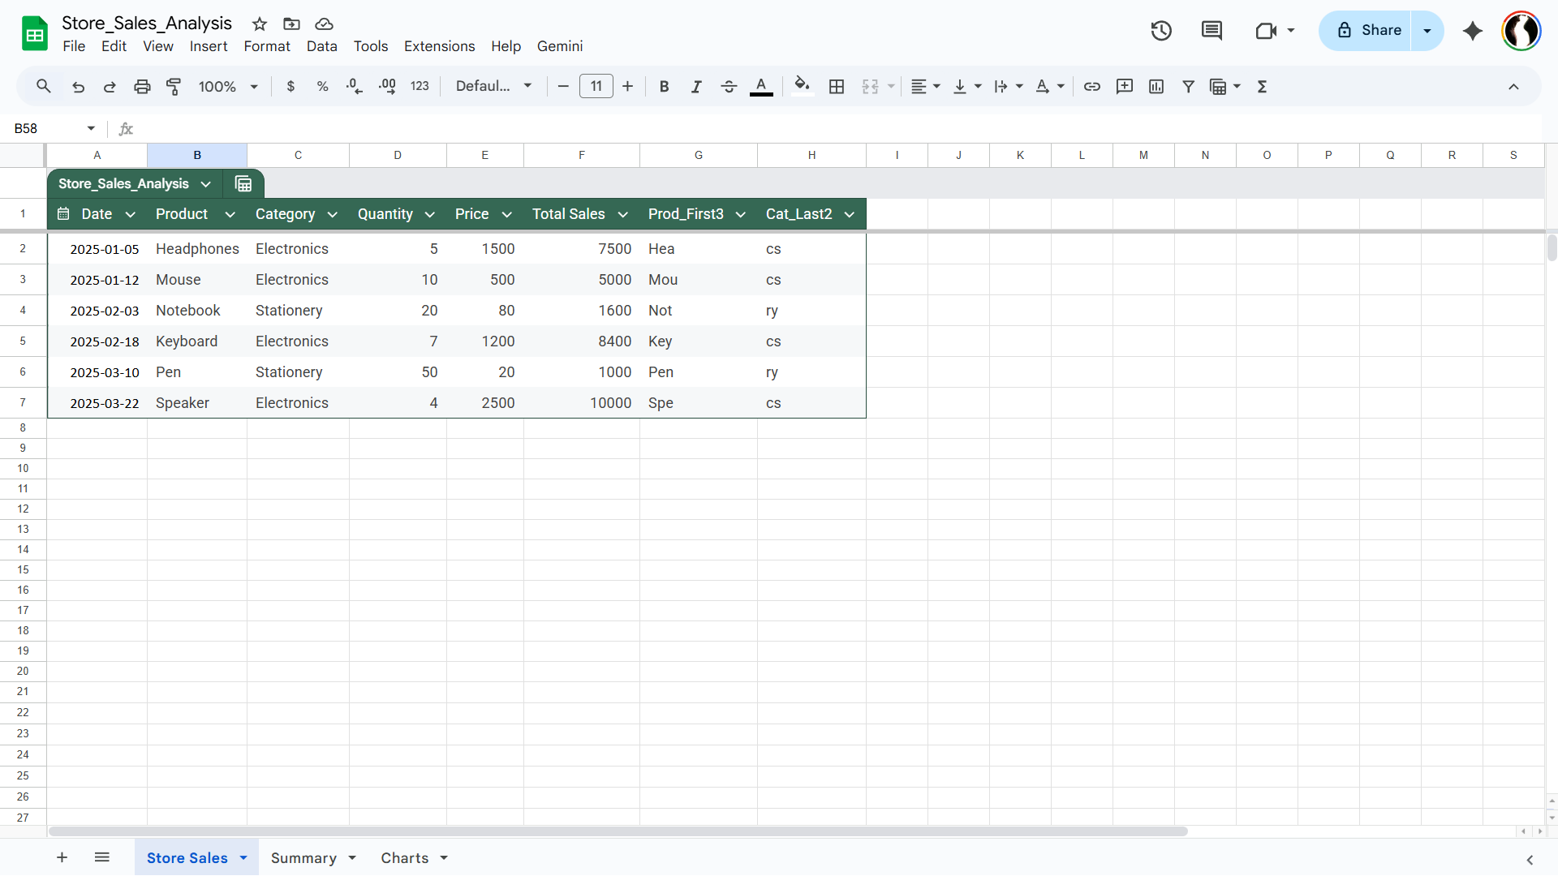

**EXPERIMENT – 15**

**OBJECTIVE: - Create a complete personal financial planner workbook.**

**(a) Create and rename sheets as:**

**i. Expenses ii. Budget iii. Charts**

**(b) Enter at least 20 rows of expense data:**

**Date, Category, Expense Detail, Amount, Payment Method.**

**(c) Use Data Validation dropdown to create a category list**

**(Food, Travel, Fees, Shopping, Other).**

**(d) Use Remove Duplicates on the Category column if repeated incorrectly.**

**(e) Use SUMIF to calculate total spending for each category.**

**(f) In the Budget sheet, create the monthly budget and compare with actual expenses using:**

**Difference = Budget – Actual (formula required)**

**(g) Highlight expenses above ₹2000 using Conditional Formatting.**

**(h) Create:**

**i. A Pie Chart showing category-wise spending**

**ii. A Bar Chart comparing Budget vs Actual**

**iii. Use Flash Fill to separate date into Day / Month / Year if needed. Also explain its details**

**iv. Save worksheet in Page Layout view and adjust print area.**

|  |  |  |  |  |  |  |  |
| --- | --- | --- | --- | --- | --- | --- | --- |
| Date | Category | Expense Detail | Amount | Payment Method | Day | Month | Year |
| 2025-01-02 | Food | Lunch | 250 | Cash | 2 | 1 | 2025 |
| 2025-01-03 | Travel | Bus Pass | 1200 | UPI | 3 | 1 | 2025 |
| 2025-01-05 | Fees | Exam Fee | 3000 | Card | 5 | 1 | 2025 |
| 2025-01-06 | Shopping | Books | 1800 | UPI | 6 | 1 | 2025 |
| 2025-01-07 | Food | Dinner | 450 | Cash | 7 | 1 | 2025 |
| 2025-01-08 | Travel | Cab | 2200 | UPI | 8 | 1 | 2025 |
| 2025-01-09 | Other | Recharge | 399 | UPI | 9 | 1 | 2025 |
| 2025-01-10 | Shopping | Shoes | 3500 | Card | 10 | 1 | 2025 |
| 2025-01-11 | Food | Snacks | 150 | Cash | 11 | 1 | 2025 |
| 2025-01-12 | Fees | Course Fee | 5000 | UPI | 12 | 1 | 2025 |
| 2025-01-13 | Travel | Train | 1800 | Card | 13 | 1 | 2025 |
| 2025-01-14 | Other | Internet | 999 | UPI | 14 | 1 | 2025 |
| 2025-01-15 | Food | Groceries | 2200 | Cash | 15 | 1 | 2025 |
| 2025-01-16 | Shopping | Clothes | 2700 | Card | 16 | 1 | 2025 |
| 2025-01-17 | Travel | Fuel | 2000 | Cash | 17 | 1 | 2025 |
| 2025-01-18 | Fees | Library Fee | 1200 | UPI | 18 | 1 | 2025 |
| 2025-01-19 | Food | Breakfast | 120 | Cash | 19 | 1 | 2025 |
| 2025-01-20 | Other | Medicine | 650 | Cash | 20 | 1 | 2025 |
| 2025-01-21 | Shopping | Bag | 1900 | UPI | 21 | 1 | 2025 |
| 2025-01-22 | Travel | Auto | 300 | Cash | 22 | 1 | 2025 |

|  |  |  |  |
| --- | --- | --- | --- |
| Category | Budget | Actual | Difference |
| Food | 5000 | 3170 | 1830 |
| Travel | 6000 | 7500 | -1500 |
| Fees | 10000 | 9200 | 800 |
| Shopping | 7000 | 9900 | -2900 |
| Other | 3000 | 2048 | 952 |

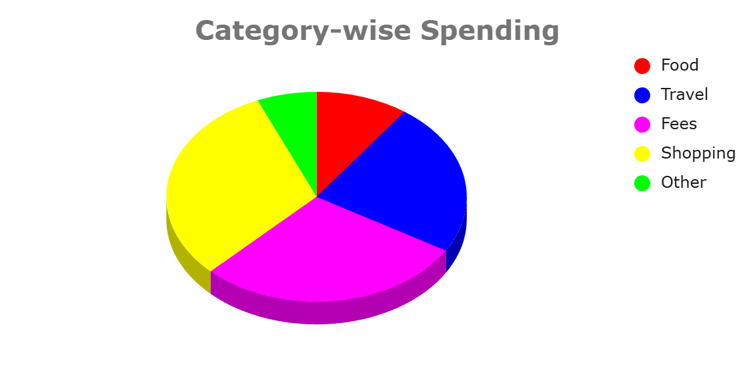

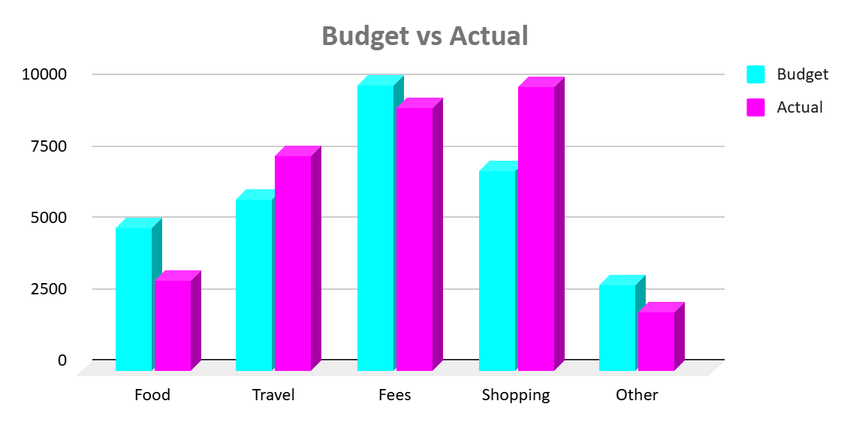

**The expense data, consisting of 20 transactions, shows a total spending of 31,818 with an average transaction amount of 1,590.9. The analysis of this data reveals key patterns in how money is spent and which payment methods are most frequently used.**

**Key Takeaways from Expense Analysis**

**1. Spending is Highly Concentrated in a Few Categories**

**The top three categories, Shopping, Fees, and Travel, account for over 83% of the total recorded expenses, indicating where the majority of the budget is allocated.**

**• Shopping is the highest spending category, totaling 9,900.**

**• Fees is the second largest category at 9,200, which includes significant one-time payments like the Exam Fee (3,000) and College Fee (6,000).**

**• Travel follows with 7,500, mainly driven by major costs such as the Flight Ticket (5,000).**

**• Food expenses are a smaller portion of the total, amounting to 3,170.**

**1. UPI and Card Payments Dominate Transactions**

**Digital payment methods like UPI and Card are the primary ways expenses are settled, representing over 80% of the total amount spent.**

**• UPI is the most preferred payment method, accounting for the largest total expenditure of 14,698.**

**• Card payments are the second most used, with a total of 11,000 spent.**

**• Cash is used for the lowest total amount, at 6,120, suggesting a preference for digital transactions, potentially for larger amounts.**

**The following charts illustrate the distribution of expenses:**

**Total Expense by Category**

**This bar chart shows the total amount spent in each expense category, clearly highlighting Shopping, Fees, and Travel as the largest contributors to overall spending.**

**Total Expense by Payment Method**

**This chart visualizes the total amount spent using each payment method, demonstrating the dominance of UPI and Card payments.**

